Squantum Head Virtual Field Trip
Student’s Name
Institution

Squantum Head Virtual Field Trip
Introduction
The class of geology was supposed to take part in a field trip; however, due to the COVID-19 pandemic, the field trip was cancelled and instead, it was conducted virtually. Nonetheless, with advanced technology, carrying out this lab report was enhanced by Google Earth (Wyatt, & Werner, 2019). The virtual field trip was performed in the unit of Boston Bay Group on its different sub-units such as Brookline Member, Dorchester Member as well as Squantum Member. The region has various types of sedimentary rocks that can be observed and identified. The virtual field trip was held to get to study the different geomorphic features present with different places in the Squaw Head. Using Google Earth enhanced the process of collecting information concerning geology features within the region.
Methods
The field trip commenced with the observation of different rocks as well as geology features at every stop (Campbell, 2017). At every stop, that was indicated on the slides, a question was answered from the worksheet. The PowerPoint slides considerably enhanced my understanding by giving me a hint concerning geomorphic features observable in the region. Some of the features included joint sets and fault offsets. Besides, there were some of the questions that the professor asked and became explained to acquaint us with an understanding of the rock and be able to identify it.
Findings
1. Find the contacts between the two different rock types on the beach.
The Cambridge Argillite overlies the Squantum Member and comprises a length of 5km of turbiditic siltstone as well as sandstone beds. Thus the nature of contact is an unconformity. The deposition of the rock masses was not continuous; thus, one rock overlies the other. Hence the older layer became exposed to erosion for significant intervals before the younger layer became deposited. The siltstone is much younger than the sandstone as it forms a layer above, while the latter forms the underneath layer.
2. What is the nature of the contact? Unconformity, Disconformity, Non-conformity, or angular unconformity?
Along the beach, the contact between the siltstone and sandstone beds forms the contact of unconformity. The siltstone has superimposed the sandstone consolidating it, thereby creating a bed (Keller et al., 2019). The contact of the siltstone and sandstone form graded beds, starved ripples, scour marks as well as micro-faults. Within the unit, there are discrete ash beds and the mega slump that folds numerous lengths.
Additionally, there is unconformity as normal faults bound the strata of the Boston Bay Group in the north and west direction. In the contact, there was unconformity between Roxbury Conglomerate and the Dedham Granite. Besides, the Roxbury Conglomerate unconformable superimposes Mattapan Volcanic Complex.
3. Look for jointing within the outcrops. Can you observe any dislocation on either side of the joint set? Is it a fault? If so, what kind of fault?
At stop 5, there is a joint set from within the outcrops. The joint set has dislocated, and a line of weakness can be seen moving laterally. The dislocation of the joint sets on the rocks was mainly caused by tensional stresses that led to stretching of the rocks. Thus the rocks developed lines of weakness that fractured. The joint sets were evident on several rocks in the region, such as sandstone and granite. The rocks developed the joint sets as they became infilled with minerals that had precipitated, cooled and solidified in the form of magma.
4. As we round the point look out into the harbor. What do you observe?
The harbor contains a large mass of clear water that with a regular shape that helps most ships or boats to dock. The presence of the natural harbor makes it possible for many crafts and ships to have enough space for loading and offloading services(Song Et al., 2020). At stop 5, there is enough space that allows for many boats to get used in the transportation of facilities. I can see the coastline at the harbor at this point being regular and is useful in providing space for many sea facilities. At stop 4, the port does not allow for many ships and boats due to its small length. The land protrudes into the seas leading to reduced space to get occupied by many ships and boats. At point 3, the coastline is regular and provides a large harbor for breaking water. Waves that might affect the nature of the landscape can get reduced through the extensive coastline.
5. As we walk along the eastern portion of Squantum Head we observe another contact. What type of contact is it?
The contact that exists at the eastern portion of the Squantum Head is the Cambridge Argillite. The connection consists of dark olive graded turbiditic siltstone as well as sandstone beds. There are a lot of structures found within the Cambridge Argillite contact such as scour marks, load casts, and starved ripples. Most trees exist within the connection with most volcanic rocks situated in the area (Song Et al., 2020). The ash beds in the contact form a large thickness that increases swelling of the soil. The stones of different kinds exist within the eastern portion of the connection. There are volcanic as well as Dedham Granite rocks. The east part consists of rocks that got reduced from large to small sediments that occupy a large portion of the basin. Cambridge Argillite contact contains many volcanic stones in the form of andesite and intrusive rocks. The connection in the eastern part forms fertile soils that help in supporting forest growth. Forests within the contact have got productive growth within the map.
6. Describe the geomorphic features that you observe. Mark and label them on the map.
At point 4, there exists a headland that forms the main geomorphic feature in the area. The cape got established as a result of erosion that occurred at the coastline (Dupré, 2019). Sides of the coastal rocks get eroded by seawater, leading to the formation of the headland that remains protruding. Besides, there are volcanic rocks at point 4 that got formed as a result of erosion of the coast—volcanic rocks within the beach from the main geomorphic features on the map. Volcanic rocks can get formed through tension or compression of stones leading to magma development. There are also beaches along the coast at points 1 and 2 along the coast. The beaches got formed as a result of deposition that got done by seawater after erosion. The rocks within the beds of the sea got deposited on the land, creating beaches. Sediments also made beaches to get formed on the coast leading to the scenic beauty. A basin exists within the forest where a large mass of water forms the main geomorphic feature on the land. Streams and rivers take their water to the pool that helps people from the area in water accessibility (Dupré, 2019). Rivers erode rocks leading to the formation of a point in which water can get gathered without leaving creating a basin. The basin in the area forms the drainage system in which water gets within the forest.
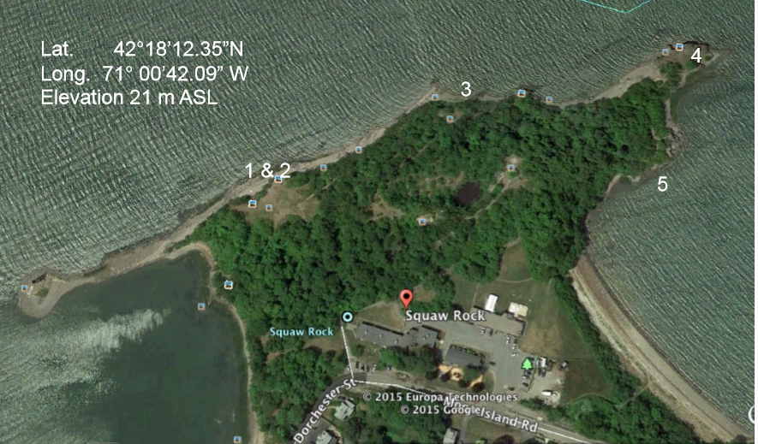
Boston Basin

Headland
Beach
Summary
The slides were also helpful in ensuring that the geology lab report was aptly performed. But it was hard to determine the texture and size of the rocks within the Boston area as the trip was done virtually. Trusteesofreservation.org, as well as Bostongeology.com, are sources that remarkably enhanced my knowledge concerning the identification of rocks within the region.
Furthermore, the virtual trips widened my knowledge concerning the diverse types of rocks that are existent within the Squatum Head. Learning about the region has improved my understanding of geomorphic features such as anticlines, rocks, and contact metamorphism that occur in areas with an expansive array of rocks. Getting to use Google Earth in the virtual geology lab report has had astronomical influence in ensuring that the assignment was done meticulously without visiting the place physically.
Conclusion
Taking a field trip to the Squaw Head, Squantum would have been a perfect move towards learning rocks in the region in real-life. However, due to the ongoing COVID-19 pandemic, the health of students was protected, and Google Earth was availed to ensure we conduct a virtual field trip. From the findings of the virtual field trip, it is apparent that the Boston Basin’s history of stratigraphy is ambiguous, untestable as well as impractical. This is because the identification of stratigraphy units cannot be confidently recognized as it is impossible to correlate with contiguous outcrop. Furthermore, the Squantum Member at Squantum is characterized by tremendous textural variability. The Boston Bay Group is the only formal stratigraphic designation that can be retained as it is undifferentiated.

References
Campbell, C. M. (2017). An inside view: The utility of quantitative observation in understanding college educational experiences. Journal of College Student Development, 58(2), 290-299.
Dupré, W. R. (2019). Geologic Controls on River Morphology and Flooding in the Southeastern Texas Coastal Region.
Keller, C. B., Husson, J. M., Mitchell, R. N., Bottke, W. F., Gernon, T. M., Boehnke, P., ... & Peters, S. E. (2019). Neoproterozoic glacial origin of the Great Unconformity. Proceedings of the National Academy of Sciences, 116(4), 1136-1145.
Song, H., Kuang, C., Gu, J., Zou, Q., Liang, H., Sun, X., & Ma, Z. (2020). Nonlinear tide-surge-wave interaction at a shallow coast with large scale sequential harbor constructions. Estuarine, Coastal and Shelf Science, 233, 106543.
Wyatt, S., & Werner, J. (2019). Using Google Earth to Support Active Learning in an Online Geology Course. Distance Learning, 16(1), 3-5.

